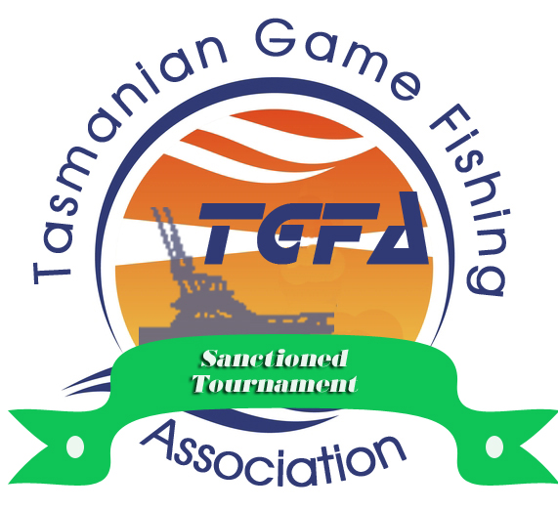

Eaglehawk Neck, Tasmania
Saturday 25th January 2025
Conducted by the Tuna Club of Tasmania Inc.


TGFA Sanctioned Contest

Entry Form must be completed and reach the Secretary of the Tuna Club of Tasmania Incorporated with the correct entry fees NO later than Friday the 17th January 2025, PO Box 507, Sandy Bay, Tas, 7006 or by email to info@tunacluboftasmania.asn.au
The entry fees can be paid EFT from your Bank Account, entry forms must be signed and mailed or emailed.
It is mandatory that you attach a copy of your current marine insurance policy and provide details on this form:
Insurance Company: Policy No: Exp Date: / / 20 .
By signing this entry form you declare that your vessel carries the required safety equipment detailed on the reverse of this entry form
Team Members ( min of 2 Anglers, max of 6 Anglers that are current financial members of a Club affiliated with GFAA )

Surname Given Name Club Age ( for Jnr & Small fry Anglers only )
Angler 1 / /
Angler 2 / /
Angler 3 / /
Angler 4 / /
Angler 5 / /
Angler 6 / /

Skippers Name:...................................................Skippers Mobile Phone Number: ………………………………………

Vessel Name Length in metres Radio Frequency
Contest Entry Fee: $40.00 Per Adult Angler & $25.00 per Junior / Small Fry Angler $_ _ _ _ _ _ _ _ _
Late Entry Fee $100.00 per Boat ( for entries received after 17th Jan 2025 ) $_ _ _ _ _ _ _ _ _
EFT Payments – Bendigo Bank – BSB : 633-000 – Account No : 219 661 782 Total $_ _ _ _ _ _
Indemnity Form – to be signed by each Entrant
The Secretary, the Tuna Club of Tasmania Inc.
Please accept our entry for the 11th Australia Day Shark and Game Fish Challenge . I/We agree to the rules as published . In consideration of you accepting Me/Us as a competitor/s or guests , I/We absolve the 11th Australia Day Shark and Game Fish Challenge organiser, officers and members,
their staff, executive, volunteers, assistants and concessionaires, any sponsors. Their officers and members, staff, executive, volunteers and concessionaires as such from any liability whatsoever and howsoever arising from my/our involvement (whether on-shore or out at sea and including any liability resulting from the acts or omissions of my/our boat owner/skipper/deckhand or other employees) in the tournament, and I/We indemnify you and agree to keep you indemnified against all claims, damages, costs and losses that may be claimed or awarded against you or that you may suffer resulting from injury or loss to us or my property of mine/ours invites, or licensees or guests . No nomination form will be accepted until all team participants have signed this indemnity and complete such details on the nomination form . Should any nomination form be accepted prior to such completion and signature, the nomination is subjected to signature of this indemnity and completion of details on this nomination form as and when requested by the Tuna Club of Tasmania Inc. I/We consent to Clubs verifying my membership status .

Signed……………………………../……………………………../……………………………../……………………………../

……………………………../……………………………../……………………………../……………………………../

Offshore Safety Equipment Requirements
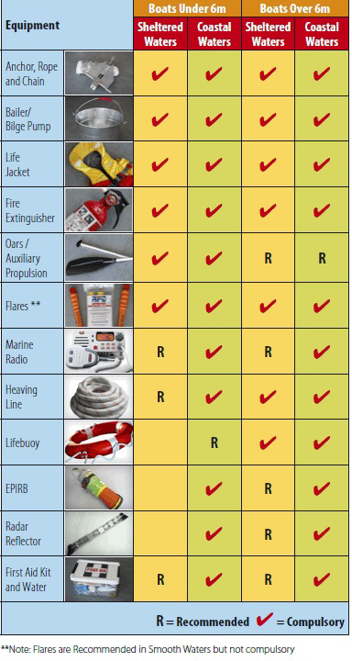
All vessels operating at night require navigational lights and torch.
It is recommended that vessels less than 6 metres should not proceed beyond sheltered waters.
Sheltered waters are all waters not exceeding 2 nautical miles to seaward of land on the North and East coasts unless specified in the MAST "Limits of Operational Areas"
All Other Waters are those beyond Sheltered Waters as well as waters on the South and West Coasts between South East Cape and Cape Grim.
Please refer to www.mast.tas.gov.au for more information on safety equipment if more detail is required.

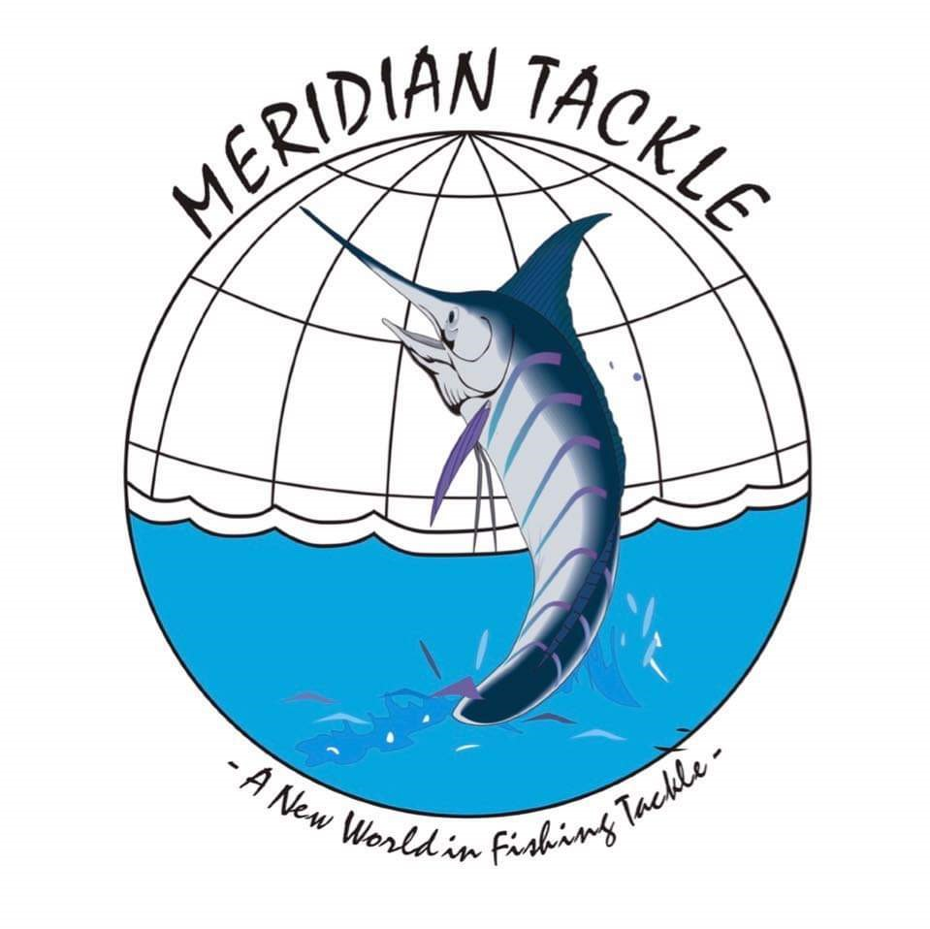



If you haven’t recently or are new to Comp fishing , please fill out this Vessel Detail Form

The Tuna Club of Tasmania Inc.

 2024 / 2025 VESSEL DETAILS FORM
Boat Owners Name : ......................................................................................................................
Address....................................................................................................................................................................................................................................................................Post Code………….
Home Phone......................................................Mobile...................................................................
Email: ..............................................................................................................................................
Boat Name : ……………………………………………… Registration No……………….
Make……………………..……… Type eg Halfcabin / flybridge, etc ….............................................
Length of boat is .…..…… Feet or ….……. Metres / Age of Hull...........................................
Hull Construction........................ Hull Colour.…......... Superstructure Colour ……...…..…..
Marine Radio Frequencies Installed :
(Tick) : VHF…. 27 MHz…. HF…. Radio Call Sign………..…………...… Radar…… Yes / No
Type of Motor : outboard / inboard . Brand............................................ H/P............
Second Motor if applicable . Brand. ........................................... H/P……....
Auxiliary Power Type . Brand............................................ H/P...........
Maximum Speed.........(Knots/Kph) Fuel Type ....................... Fuel Capacity............(Litres)
Motor Vehicle Details :

Make:............................................................ Model.......................................................

Year ................. Colour............................ Registration number................................

Trailer Make........................................ Registration number.................................
Boat Insurance Details :
Company Insured.................................. Policy No......................... Exp Date..........
It is a Tuna Club of Tasmania Inc. requirement that all boats are registered, seaworthy and owners must provide evidence of full comprehensive insurance before they compete in any club competitions or contests. All boats must comply with all minimum safety regulations as outlined by MAST (Marine and Safety Tasmania)

I ...............................................................am the registered Owner/skipper of the above vessel and declare that all the above information is true and correct

Aust Day Comp Signed.....................................................................................Date....../....../ 20….

